When you compile and run a C program that prints "Hello, World!", the program interacts with the operating system through system calls to perform tasks like writing output to the terminal. Below is a step-by-step explanation of how a simple "Hello, World!" program in C converts to system calls and executes them in the operating system

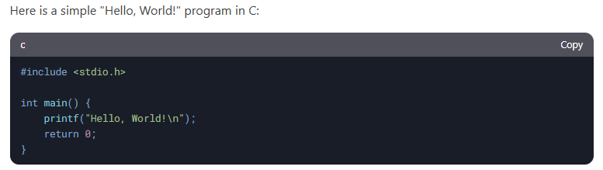
When you compile the program using a C compiler (e.g., gcc), the compiler translates the C code into machine code (an executable file). For example:
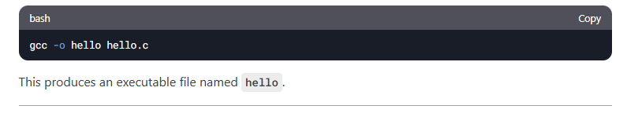
When you execute the program:
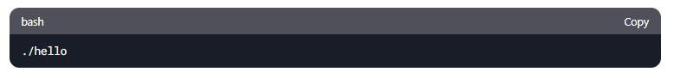
The operating system loads the executable into memory and starts executing it.

The printf function in the C standard library (stdio.h) eventually makes a system call to the operating system to perform the actual task of writing "Hello, World!" to the terminal.

Here's how it works:

a. printf Internals
The printf function formats the string "Hello, World!\n" and passes it to the write system call. The write system call is used to write data to a file descriptor (in this case, the standard output, which is typically file descriptor 1).

b. System Call Invocation
The C standard library (glibc on Linux) provides a wrapper for the write system call.

The write system call is invoked with the following parameters:

File descriptor (1 for standard output).

Pointer to the buffer containing the string "Hello, World!\n".

Number of bytes to write (14 bytes, including the newline character).

The write system call traps into the kernel (via a software interrupt or a special instruction like syscall on x86-64).

The kernel handles the request, writes the data to the terminal, and returns control to the user-space program. You can use a tool like strace on Linux to trace the system calls made by the program. Run:

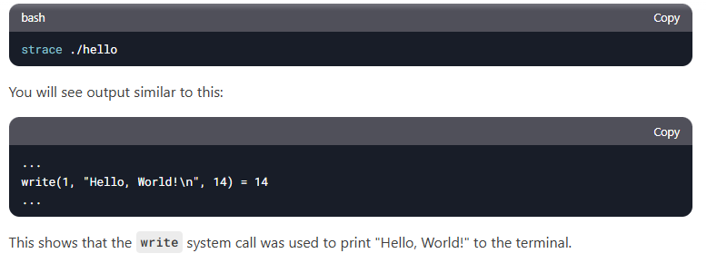

Here’s a simplified flow of how the program interacts with the OS:

- The program calls printf.

- printf formats the string and calls write.

- write invokes a system call (e.g., syscall instruction on x86-64).

- The CPU switches to kernel mode, and the OS kernel handles the request.

- The kernel writes the data to the terminal.

- Control returns to the user-space program, which exits.

- write: Writes data to a file descriptor.

- exit: Terminates the program (called implicitly when main returns).

If you disassemble the executable (e.g., using objdump), you can see the assembly instructions that invoke the system call. For example:

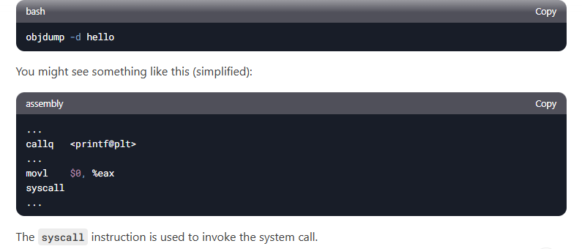

The system call handler is a critical component of the operating system (OS) that plays a central role in facilitating communication between user-space programs (like your C program) and the kernel. In the case of the "Hello, World!" program, the system call handler is responsible for managing the transition from user mode to kernel mode and executing the requested system call (e.g., write).

What is a System Call Handler?

The system call handler is a part of the operating system kernel. It acts as an intermediary between user-space programs and the kernel. When a program needs to perform a privileged operation (e.g., writing to the terminal, accessing hardware, or managing memory), it makes a system call. The system call handler ensures that the system call is executed securely and efficiently.

Role of the System Call Handler in the "Hello, World!" Program

- Intercepting the System Call

When the printf function in your C program is called, it eventually invokes the write system call to output "Hello, World!" to the terminal. The write system call is a request to the OS to perform a low-level operation (writing data to a file descriptor). The system call handler intercepts this request.

- Switching from User Mode to Kernel Mode

User-space programs run in user mode, which has restricted access to hardware and kernel resources. To perform privileged operations, the CPU must switch to kernel mode. The system call handler facilitates this switch: On x86-64 architectures, this is typically done using the syscall or int 0x80 instruction. The system call handler sets up the necessary environment for kernel-mode execution.

c. Validating the System Call

The system call handler checks the validity of the system call: It ensures that the system call number (e.g., __NR_write for the write system call) is valid. It verifies that the arguments passed to the system call (e.g., file descriptor, buffer pointer, and byte count) are valid and accessible by the program.

d. Executing the System Call

Once the system call is validated, the system call handler invokes the appropriate kernel function to perform the requested operation.
For the write system call: The kernel writes the data ("Hello, World!\n") to the specified file descriptor (standard output, which is typically file descriptor 1). The kernel ensures that the data is sent to the terminal or output device.

e. Returning to User Mode
After the system call is executed, the system call handler prepares the return value (e.g., the number of bytes written). It switches the CPU back to user mode and returns control to the user-space program.

System Call Handler in Action: Example
Here’s a step-by-step breakdown of how the system call handler works in the "Hello, World!" program:

User-Space Program: The program calls printf("Hello, World!\n");. Internally, printf invokes the write system call.

System Call Invocation: The program executes a special instruction (e.g., syscall on x86-64) to trigger the system call. The CPU switches to kernel mode, and control is transferred to the system call handler.

System Call Handler: The handler validates the system call number and arguments. It invokes the kernel's write function to perform the operation.

Kernel Execution: The kernel writes "Hello, World!\n" to the terminal. It returns the number of bytes written (14 in this case) to the system call handler.

Return to User Mode:The system call handler switches the CPU back to user mode. The program resumes execution, and the return value is passed back to the user-space program.

System Call Handler in Linux

In Linux, the system call handler is implemented in the kernel. Here’s a high-level overview of how it works:

System Call Table: The kernel maintains a table of system call numbers and their corresponding functions. For example:

__NR_write corresponds to the sys_write function.

Entry Point: When a system call is invoked, the CPU jumps to a predefined entry point in the kernel (e.g., entry_SYSCALL_64 on x86-64).

Handler Function: The system call handler looks up the system call number in the table and calls the appropriate kernel function.

What is the write System Call?

The write system call is used to write data to a file descriptor. It is commonly used to output data to the terminal (standard output) or write to files. It is a low-level function provided by the operating system.

Syntax of the write System Call

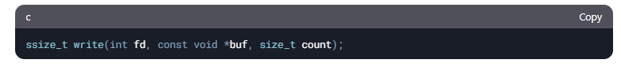

Parameters:

fd (File Descriptor):
This is an integer that represents the file or device to which the data will be written.

Common file descriptors:

0: Standard Input (stdin)

1: Standard Output (stdout)

2: Standard Error (stderr)

buf (Buffer):
This is a pointer to the data you want to write. For example, if you want to write a string, this would point to the string.
count (Byte Count):
This is the number of bytes to write from the buffer. For example, if you are writing a string, this would be the length of the string.

Return Value:
On success, write returns the number of bytes written. On failure, it returns -1, and an error code is set in errno.

Sample Program Using the write System Call

Here’s a simple C program that uses the write system call to print "Hello, World!" to the terminal:
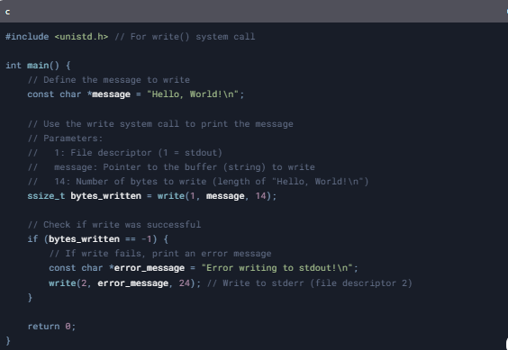

Explanation of the Program

Include the Header:

#include <unistd.h>: This header file provides the declaration for the write system call.

Define the Message:

const char *message = "Hello, World!\n";: This is the string we want to write to the terminal.

Call the write System Call:

write(1, message, 14);

1: File descriptor for standard output (stdout).

message: Pointer to the string we want to write.

14: Number of bytes to write (length of "Hello, World!\n" including the newline character).

Check for Errors:

If write fails, it returns -1. In this case, we print an error message to standard error (stderr) using write(2, error_message, 24);.

Return from main:

The program returns 0 to indicate successful execution.

How to Compile and Run the Program

Save the program to a file, e.g., write_example.c.
Compile the program using gcc:

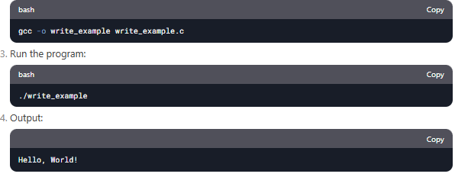

Key Points to Remember

The write system call is a low-level function for writing data to file descriptors. It requires three parameters: the file descriptor, a buffer (pointer to the data), and the number of bytes to write. Always check the return value of write to handle errors. File descriptors 0, 1, and 2 are predefined for stdin, stdout, and stderr, respectively.

Why Use write Instead of printf?

printf is a higher-level function that internally uses write to output data. Using write directly gives you more control over low-level operations, which is useful in systems programming.

How Parameters are Passed in System Calls

When a program makes a system call, it often needs to pass some data (parameters) to the operating system. For example: If you want to read a file, you need to pass the file name, the buffer to store the data, and the number of bytes to read. If you want to create a process, you need to pass the program name and arguments.

There are three common ways to pass parameters in system calls:

- Passing Parameters in Registers

How it works: The parameters are stored directly in the CPU registers.
Why it's fast: Registers are the fastest memory in a computer.
Limitation: Registers are limited in number, so only a few parameters can be passed this way.
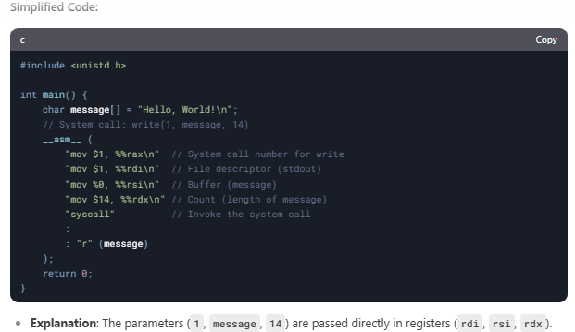

- Passing Parameters in a Block (Memory)

How it works: The parameters are stored in a block of memory (e.g., an array or struct), and the address of that block is passed in a register.
Why it's flexible: You can pass a large number of parameters.
Limitation: Slightly slower because memory access is slower than register access.

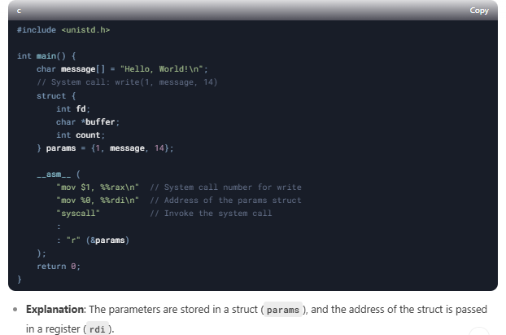

3.Passing Parameters on the Stack

How it works: The parameters are pushed onto the stack (a special memory area used for function calls).
Why it's simple: The stack is easy to use and automatically managed by the CPU.
Limitation: Slower than registers, but still faster than general memory.

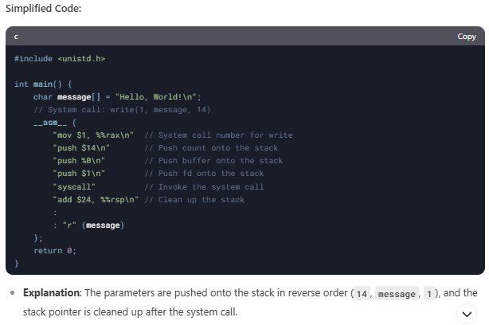

Which Method is Used?

Most modern operating systems (like Linux) use a combination of registers and memory blocks for passing parameters in system calls.

For example, in Linux:

The system call number is passed in the rax register.

Up to 6 parameters are passed in registers (rdi, rsi, rdx, r10, r8, r9).

If there are more than 6 parameters, they are passed in a memory block.

